H.T No
Regulations:
A17

Sreenidhi Institute of Science and Technology
(An Autonomous Institution)
Code No: 6AC48 Date: 08-Mar-2021 (AN)

B.Tech II-Year II- Semester External Examination, March/April - 2021 (Supplementary)
Elements of Electrical and Electronics Engineering (ME)

Time: 3 Hours Max.Marks:75

Note: a) No additional answer sheets will be provided.
b) All sub-parts of a question must be answered at one place only, otherwise it will not be valued.
c) Missing data can be assumed suitably.

ANSWER ANY 5 OUT OF 8 QUESTIONS. EACH QUESTION CARRIES 15 MARKS.

Bloom's Cognitive Levels of Learning (BCLL)

Remember | L1 | Apply | L3 | Evaluate | L5
Understand | L2 | Analyze | L4 | Create | L6

 |  |  | BCLL | CO(s) | Marks
1. | a) | Explain different methods of excitation of D.C. generators with suitable diagrams. | L2 | CO1 | [8M]
 | b) | Find the resistance between the points A and B in the series-parallel network shown in below Fig  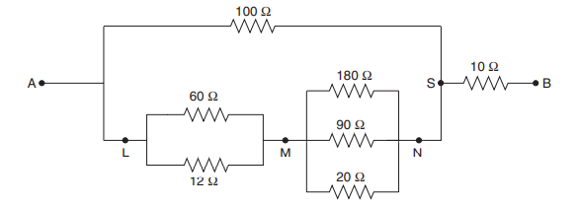 | L3 | CO1 | [7M]
2. |  | Deduce an expression for power in a 3-phase balanced load circuit. Show that it is the same irrespective of the load being connected in star or delta. | L3 | CO2 | [15M]
3. | a) | Describe with a neat diagram, the principle of operation of induction motor. | L2 | CO3 | [8M]
 | b) | Differentiate between an absolute instrument and a secondary instrument. | L2 | CO3 | [7M]
4. | a) | Enumerate the list of different filters used in rectifier and mention their merits and demerits. | L2 | CO4 | [8M]
 | b) | Explain the terms: Positive clipper, Negative clipper, Biased clipper. | L2 | CO4 | [7M]
5. | a) | Draw the circuits of the various transistor configurations and list their important features. | L3 | CO5 | [11M]
 | b) | Give reasons why CE configuration is mainly used? | L3 | CO5 | [4M]
6. | a) | Simplify the following Boolean expression using four variables K-map and draw the logic diagram using NAND gates only.  f(w,x,y,z)= ∑m(0, 1, 3, 4, 6, 9, 11) + ∑d(2, 5) | L3 | CO6 | [8M]
 | b) | State De-Morgan’s theorems. | L1 | CO6 | [7M]
7. | a) | Find the current through the 2Ω resistor of the network in below Figure. The presence of three sources results in three different networks to be analyzed.  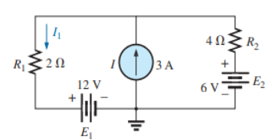 | L3 | CO1 | [5M]
 | b) | Define the following terms as applied to an alternating current: Cycle, frequency, time period, amplitude. | L2 | CO2 | [5M]
 | c) | Give the importance of controlling torque in the measuring instruments. | L2 | CO3 | [5M]
8. | a) | Describe the function of the Clamper circuit. Mention whether the original signal change at the output of the Clamper circuit? | L3 | CO4 | [5M]
 | b) | What is the role of substrate in MOSFET operation? | L2 | CO5 | [5M]
 | c) | Define the terms ‘logic function’ and ‘logic gate’ and draw symbols of different logic gates. | L1 | CO6 | [5M]

-- 00 -- 00 –

